ACT 471 Assignment 3

Part 3: Government and Industry Insurance Programs

1. (7 points)
   1. (1 point) Briefly describe 2 methods of loss subsidization that the government insurer can use to fill insurance needs unmet by private insurance
   2. (2 points) Identify and briefly describe 2 reasons for government participation in insurance, other than to fill insurance needs unmet by private insurance.
   3. (1 point) For each of the reasons provided in part b., briefly describe 1 situation in which the reasoning for government participation may not be justified
   4. (3 points) Identify 3 evaluation criteria for government insurance programs and evaluate the performance of the Québec's public automobile insurance plan based on these criteria.
2. (6 points)
   1. (3 points) Describe 3 reasons for historical limited availability of flood insurance in Canada
   2. (1 point) Explain 1 precondition that is essential to establishing a strong flood risk management culture which is not included within your response to part a.
   3. (1 point) Explain why government involvement in a national flood program may still be needed to supplement the flood coverage offerings from private insurers.
   4. (1 point) Flood coverage for personal property has not been typically offered by private insurers in Canada. Describe 1 reason why insurers have historically paid for a large proportion of these losses.
3. (2 points) Identify 2 similarities and 2 differences between the Ontario and Alberta RSPs.
4. (6.5 points) The following information is provided for the RSP in Nova Scotia. All amounts are in 000’s.

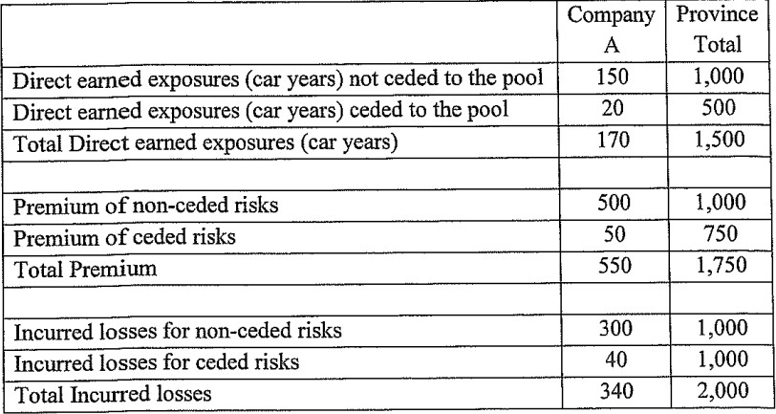

Company A exclusively writes business in Nova Scotia and their usage is below the RSP maximum total allowable transfer limit. Assume expenses are 0%.

* 1. (1 point) Calculate the loss ratio for Company A on their share of the risk-sharing pool
  2. (1 point) Calculate the total loss ratio for Company A which includes the results of the risk sharing pool
  3. (1.5 points) Suppose the above information were for Ontario. Calculate the difference in participation ratio for Company A.
  4. (2.5 points) Calculate the revised total loss ratio for Company A if they choose not to cede any risks to the RSP
  5. (0.5 points) Propose how the company can use the RSP to lower its total loss ratio.